University of Miami

**Department of Mechanical and Aerospace Engineering**

**Undergraduate Summer Research Report**

**Owen Duffy**

**Summer of 2025, June 9 - August 1**

**Mentor: Dr. Chunlei Wang**

**Coral Gables, Florida 33143**

**1. Abstract**

This paper follows the process used to restore and improve a DIY laser engraver with multi laser compatibility and the goal of achieving LIG fabrication. The first step was identifying parts to learn the functionality of each component which were stepper motor drivers, stepper motors and Arduino Nano. Successfully wired each component between each other and the Arduino Nano for compatibility with the GRBL1.1 firmware used for laser engraving. After achieving functionality bracket prototypes were designed in CAD to integrate a 405 nm laser to replace the original 450 nm laser. This new prototype bracket attached the new laser to the original bracket and features a hook and lock system to maintain stability under operation. The attachment is printed from PETG for flexibility and improved heat resistance. The 405 nm laser engraved in wood and Kapton tape with successful carbonization. The success on Kapton tape opens the door for future engraving of LIG.

**2. Introduction**

This project was conducted over a span of two months starting with the foundations of an old project of the research group. Provided with a broken DIY laser engraver the task was to rebuild the system to full functionality. The long-term goal is to fabricate LIG (Laser Induced Graphene) electrodes. The importance of LIG electrodes is that they offer very high conductivity for a much more affordable cost, offering a wide variety of applications. To achieve this the system needed to be rebuilt, adapted to work with a strong enough laser to carbonize, and be capable of repeating tasks for continuous usage.

**3.1 Component Identification**

The process began by assessing the previous project and figuring out what components were used, how they worked, and what purpose they serve. Immediately the stepper motors drivers stuck out. Brief research revealed they were stepper driver motors (TB6600), and this allowed me to investigate their purpose. The importance of the stepper driver is to send signals that create the precise movements of the stepper motors. They are essential for stepper motors that are being used in this type of project where low resolution is key for laser engraving and 3D printing. Each driver was set to the most precise setting allowing for 1.8° micro steps.

Figure 1 - TB6600 Microstep driver (Left) and Nema 23 Bipolar stepper motor (Right)

The Nema 23 bipolar stepper motor drivers shown are what allow for precise movement control in the three axes for this laser engraver. Along with these main components was a 5V Arduino Nano with a laser module (GOOD LASER A-11-4). The Arduino Nano served as the microcontroller and for this project GRBL 1.1 firmware was loaded onto the Arduino nano board. The laser PCB creates a PWM connection between the Nano and the laser allowing for “Dynamic Control” while engraving allowing the G-code software to manipulate the laser power to ensure smooth engraving during stepper motor operation and change in direction.

Figure 2 - Laser PCB (Left) and 5V Arduino Nano (Right)

**3.2 Wiring**

At the start of the project the system was almost completely disconnected so the clear next step was to investigate where each wire goes to facilitate full function. The stepper drivers have a “High Voltage” section as shown in Figure 1, and these are the phoenix contacts for the stepper motors’ wires. During the component research there were wiring diagrams provided for the motors, however this proposed a challenge in that the cable color code on the stepper motors did not match any of the available wiring diagrams. And so, a multimeter was used to test for resistance in the cable pairings since we have a bipolar motor it is known that there will be two closed loops. Once the wire pairings are found it was guess and check to find which terminals they align with. This was performed using a test bench made with an Arduino UNO and C++ code to generate rotation in the stepper motor.

Figure 3 - Test bench used for stepper motors

All the terminals are filled for the stepper driver as shown in figure 3, this is the wiring used for all the drivers with the leftmost wires being responsible for the 12V power and ground and the rightmost wires being connected to digital PWM pins on the Arduino to control the “Signal” terminals.

Figure 4 - Test bench wiring diagram

Figure 5 - Complete wiring diagram

The test bench was scaled up to the full operating design using the same connections but with 3 stepper drivers and motors. The final wiring needed was the limit switches which were dependent on the Arduino to regulate which axes they covered. The limit switches are the key to the calibration/homing system, and this cycle runs prior to each job assisting the machine to recognize boundaries and coordinate position since stepper motors cannot remember their movements.

**3.3 Laser Improvement**

To reach the long-term goal of LIG the system needed an upgrade to the laser. The machine initially had installed a 450 nm blue diode laser which is not practical for engraving applications and carbonization. And so, a more powerful laser was acquired at 0.5W and 405 nm wavelength this violet laser was capable of carbonization, but the design constraint is there is no place to mount it. This led to the design of an adapted bracket in SOLIDWORKS. As shown in Figure 6 the initial mounting screws for the blue diode laser bracket are a smaller distance apart than the entire 405 nm laser.

Figure 6 - Original blue diode (Left) and design of new adapted bracket (Right)

The bracket design in Figure 6 was focusing on the fitment of the laser inside to have a solid hold on the laser to minimize any vibrations or slipping under operation. The adapted bracket replicates the original design while enabling a “hot swap” feature, allowing seamless use of both lasers. To continue the development of the bracket 3 other potential models were designed to support the new laser addition as shown in Figure 7.

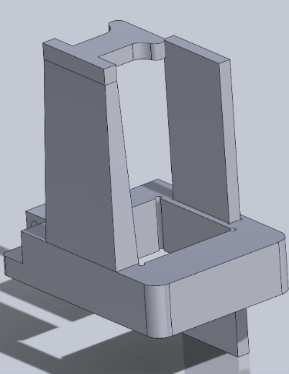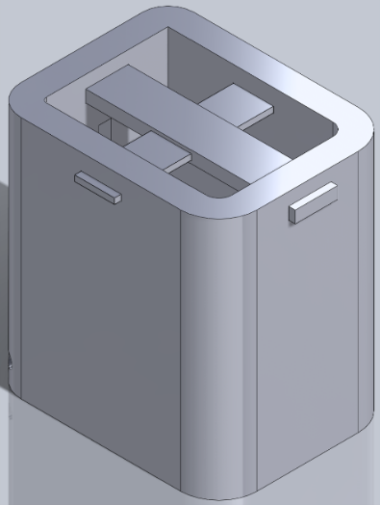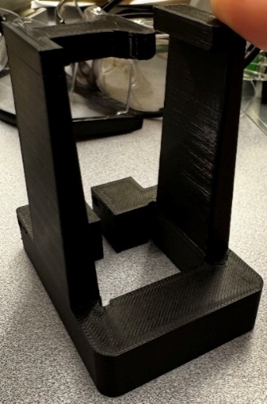

Figure 7 - Other bracket CAD designs (Left and Center) and a printed prototype (Right)

After creating multiple potential models for laser integration, a trade study was performed to decide the most effective bracket to engrave with the more powerful laser.

Figure 8 - Laser integration subsystem trade study featuring 6 ways to mount lasers comparing over 11 weighted criteria

The designs were narrowed down to two and thus the adapted bracket with sliding lock plate was chosen to move forward in the prototyping process as shown by the green “Total” cell.

**3.4 Fabrication and Iteration of the 405 nm laser bracket**

For the fabrication to keep a low fidelity prototype the model was 3D printed using PETG (Polyethylene Terephthalate Glycol). This decision was made to improve heat resistance for the possibility of the laser overheating as well as to improve the flexibility of the bracket without sacrificing structural integrity for the pinch end that tightens with a nut and bolt.

Figure 9 - Sliding lock bracket fitted (Left) and a simple operation of the laser with bracket (Right)

The sliding lock bar is in bending as shown in Figure 9 to create a more secure hold onto the laser and stability to the original mounts. This poses challenges to maintain tool head center point. However, this potential proves to be nearly neglected if the laser maintains a near vertical position since operation occurs well inside of the build plate. This is exemplified on the right side of Figure 9 where the bracket performed a simple engraving of a square. This test was performed at 100% power to ensure engraving and potential carbonization as well as the sequence was repeated 20 times to check for potential drift in the system. This design was successful, but the pressure hold isn’t reliable, so this design experienced multiple iterations to create the most stable system.

Figure 10 - Original to iterated model

Figure 10 shows the main iterations made for the bracket. Firstly, the camber was removed from the hook tower since the camber was causing a problem with tilt from the slanted surface not creating flush contact with the current laser bracket. Secondly, the additional lock bar was implemented to provide normal support in the other direction to mitigate and absorb any vibration that may occur outside of the main supports. Lastly, the modification to the main lock bar was cut into a hook and this allows for a solid connection between the adapted and original laser bracket to solidify stability in that direction.

Figure 11 - Final iteration to the main lock bar

The final iteration as shown in Figure 11, the hook needed to be cut as shown in the red circle to fix clearance issues with the limit switch. This change keeps the near perfect fitment of the hook-on screw setup without sacrificing operation. As well as the rounded off bottom edge provided ease of access for sliding the lock bar into the bracket slot.

**4. Laser Engraving**

**4.1 Software for laser engraving operation**

With fully functional components the final stage needed a way to send G-code to the GRBL 1.1 firmware on the Arduino Nano. To do this two softwares were tested LightBurn and LaserGRBL. LightBurn is a common laser engraving software that has a ton of fine-tuning features as well as a built-in vector drawing software. In contrast, LaserGRBL doesn’t have this vector drawing software and so Inkscape was used to create the vector drawing, and those were imported into LaserGRBL to convert them into G-code for the Arduino Nano to interpret.

**4.2 Substrates**

To support the long-term goal of fabricating LIG electrodes testing was done on different surfaces to see if the laser was able to carbonize the surface. The initial testing happened on aluminum which as expected wasn’t carbonizing. Next, engraving was performed on wood and thus lead to carbonization from the wood. The most important surface tested was Kapton tape since this is the most probable material to use for further research. The Kapton tape was successfully carbonized through the engraving process which opens a lot of doors for future applications as seen in Figure 12. Lastly, acrylic was tested, and the laser was able to discolor the surface but could not engrave. For the proof of carbonization, a multimeter was used testing for resistance reading that returned greater than one had been successfully carbonized.

Figure 12 - Carbonization on Kapton tape from laser engraving

**5. Conclusion**

In the end, the original DIY laser engraver was fully functional and a working 405 nm laser. The laser engraver now has capabilities with two different lasers which allow for a wide range of applications. The addition of the second laser through CAD modeling and 3D printing was a long and thought-out process using continuous prototypes to improve the mode sequentially enabling full operation of a much more powerful laser. The success of carbonization from engraving on Kapton tape opens many doors for continued research of fabricating LIG, printing circuit boards, and potential semi-conductor replacements.

The next step for this process is to continue testing carbonization on other surfaces to find which offers the best opportunity to fabricate LIG electrodes.